SLEIPNER
Hydraulic thruster & stabilizer systems
Customer questionnaire

Customer:

Contact name: Date:
Company name: Phone:
Address: Email:
ZIP Code:
City: Country:

Vessel:

Vessel type: Vessel name: Build year:
Yard name: Hull No: Hull Material:
Components to run:

 | Bow thruster |  | Anchor winch |  |  |  | Pcs |  |  |  | Capstan: |  |  | Pcs
 | Stern thruster |  | Stabilizers |  |  |  | Pcs |  |  |  | Other:
 | Other: |  |  |  | Other: |  |  |  |  |  |  | Other:
 | Other: |  |  |  | Other: |  |  |  |  |  |  | Other:
Desired thruster performance and tunnel diameter:

Bowthruster: kg thrust | Sternthruster: kg thrust
Preferred tunnel diameter (i.d.): mm | Preferred tunnel diameter (i.d.): mm
Thruster motor type: DC AC HYD | Thruster motor type: DC AC HYD

Desired control system:

Voltage of electrical system: |  |  |  |  | 12V |  |  |  |  |  |  | 24V
Number of thruster control stations: |  |  |  |  | Pcs
Number of stabilizer control stations: |  |  |  |  | Pcs
Type of control system: |  |  |  |  |  | On / off |  |  |  |  | Proportional
If proportional: |  | Type of joystick: |  |  |  | Yacht type |  |  |  |  | Pro type

System duty type and desired cooling setup:

System duty type: |  |  |  | Light Leisure |  |  | Medium Leisure
 |  |  |  | Medium Commercial |  |  | Heavy Commercial
Cooling water supply: |  |  |  | Existing/own water supply.  Water flow must be controlled! |  |  | Sleipner HYD driven centrifugal cooling pump.
 |  |  |  | Sleipner 12V brush motor centrifugal pump |  |  | Sleipner 24V brush motor centrifugal pump

SLEIPNER
Hydraulic thruster & stabilizer systems
Customer questionnaire

Requirements of additional hydraulic components:

Anchor winch |  |  |  | Anchor winch |  |  |  | Capstan |  |  |  |  | Capstan |  |  |  | Crane
1. Control system |  |  |  | 1. Control system |  |  |  | 1. Control system |  |  |  |  | 1. Control system |  |  |  | 1. Control system
 |  | On / off |  |  |  | On / off |  |  |  |  | On / off |  |  |  | On / off |  |  |  |  | On / off
 |  | Proportional |  |  |  | Proportional |  |  |  |  | Proportional |  |  |  | Proportional |  |  |  |  | Proportional
2. Pressure requirement |  |  |  | 2. Pressure requirement |  |  |  | 2. Pressure requirement |  |  |  |  | 2. Pressure requirement |  |  |  | 2. Pressure requirement
 |  |  | bar |  |  |  | Bar |  |  |  |  | Bar |  |  |  | Bar |  |  |  |  | Bar
3. Flow requirement |  |  |  | 3. Flow requirement |  |  |  | 3. Flow requirement |  |  |  |  | 3. Flow requirement |  |  |  | 3. Flow requirement
 |  |  | Liters/min |  |  |  | Liters/min |  |  |  |  | Liters/min |  |  |  | Liters/min |  |  |  |  | Liters/min

. . . . . . . . . . . . . . |  |  |  | . . . . . . . . . . . . . . |  |  |  | . . . . . . . . . . . . . . |  |  |  |  | . . . . . . . . . . . . . . |  |  |  | . . . . . . . . . . . . . .
1. Control system |  |  |  | 1. Control system |  |  |  | 1. Control system |  |  |  |  | 1. Control system |  |  |  | 1. Control system
 |  | On / off |  |  |  | On / off |  |  |  |  | On / off |  |  |  | On / off |  |  |  |  | On / off
 |  | Proportional |  |  |  | Proportional |  |  |  |  | Proportional |  |  |  | Proportional |  |  |  |  | Proportional
2. Pressure requirement |  |  |  | 2. Pressure requirement |  |  |  | 2. Pressure requirement |  |  |  |  | 2. Pressure requirement |  |  |  | 2. Pressure requirement
 |  |  | bar |  |  |  | Bar |  |  |  |  | Bar |  |  |  | Bar |  |  |  |  | Bar
3. Flow requirement |  |  |  | 3. Flow requirement |  |  |  | 3. Flow requirement |  |  |  |  | 3. Flow requirement |  |  |  | 3. Flow requirement
 |  |  | Liters/min |  |  |  | Liters/min |  |  |  |  | Liters/min |  |  |  | Liters/min |  |  |  |  | Liters/min

System powering options :

ENGINE | 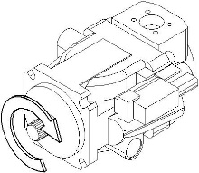  Number of engines: Engine Model:  Max rpm: rpm Power: hp / kW  Idle rpm: rpm Power / Torque at idle: kW / Nm  PTO on engine: Yes No PTO flange type: 2-bolt 4-bolt  PTO spline type (SAE J744)  SAE-A (9T) SAE-AA (11T) SAE-B (13T) SAE-BB (15T)  SAE-C (14T) SAE-CC (17T) SAE-D (13T) SAE-E (13T)  SAE-F (15T) Other: Engine PTO torque limit: Nm  Pump drive direction is defined facing the pump shaft. Example shows a clockwise rotating pump. As installed face to face, pump rotation will be opposite of PTO rotation  Pump drive direction (see illustration): Clockwise (CW)  Counter Clockwise (CCW)  Front mounted on engine with  bracket and flexible coupling: Yes No  Engine front torque limit: Nm  Pump drive direction (see illustration): Clockwise (CW) Counter Clockwise (CCW)
GEARBOX | Gearbox model:  PTO on gearbox: Yes No PTO flange type: 2-bolt 4-bolt  PTO spline type (SAE J744)  SAE-A (9T) SAE-AA (11T) SAE-B (13T) SAE-BB (15T)  SAE-C (14T) SAE-CC (17T) SAE-D (13T) SAE-E (13T)  SAE-F (15T) Other:  Pump drive direction is defined facing the pump shaft. Example shows a clockwise rotating pump. As installed face to face, pump rotation will be opposite of PTO rotation  Gearbox PTO torque limit: Nm  Pump drive direction (see illustration): Clockwise (CW)  Counter Clockwise (CCW)

SLEIPNER
Hydraulic thruster & stabilizer systems
Customer questionnaire

GENERATOR #1 | Generator Model: Power rating: kW / kVA  AC power output: : 1-phase 3-phase 110/115V 220/230V 400/440V  50Hz 60Hz  Generator PTO: Yes No PTO flange type: 2-bolt 4-bolt  PTO spline type (SAE J744)  SAE-A (9T) SAE-AA (11T) SAE-B (13T) SAE-BB (15T)  SAE-C (14T) SAE-CC (17T) SAE-D (13T) SAE-E (13T)  SAE-F (15T) Other: Engine PTO torque limit: Nm  Pump drive direction is defined facing the pump shaft. Example shows a clockwise rotating pump. As installed face to face, pump rotation will be opposite of PTO rotation  Pump drive direction (see illustration): Clockwise (CW)  Counter Clockwise (CCW)  Front mounted on generator engine with  bracket and flexible coupling: Yes No  Engine front torque limit: Nm  Pump drive direction (see illustration): Clockwise (CW) Counter Clockwise (CCW)
GENERATOR #2 | Generator Model: Power rating: kW / kVA  AC power output: : 1-phase 3-phase 110/115V 220/230V 400/440V  50Hz 60Hz  Generator PTO: Yes No PTO flange type: 2-bolt 4-bolt  PTO spline type (SAE J744)  SAE-A (9T) SAE-AA (11T) SAE-B (13T) SAE-BB (15T)  SAE-C (14T) SAE-CC (17T) SAE-D (13T) SAE-E (13T)  SAE-F (15T) Other: Engine PTO torque limit: Nm  Pump drive direction is defined facing the pump shaft. Example shows a clockwise rotating pump. As installed face to face, pump rotation will be opposite of PTO rotation  Pump drive direction (see illustration): Clockwise (CW)  Counter Clockwise (CCW)  Front mounted on generator engine with  bracket and flexible coupling: Yes No  Engine front torque limit: Nm  Pump drive direction (see illustration): Clockwise (CW) Counter Clockwise (CCW)

Stabilizer calculation data :
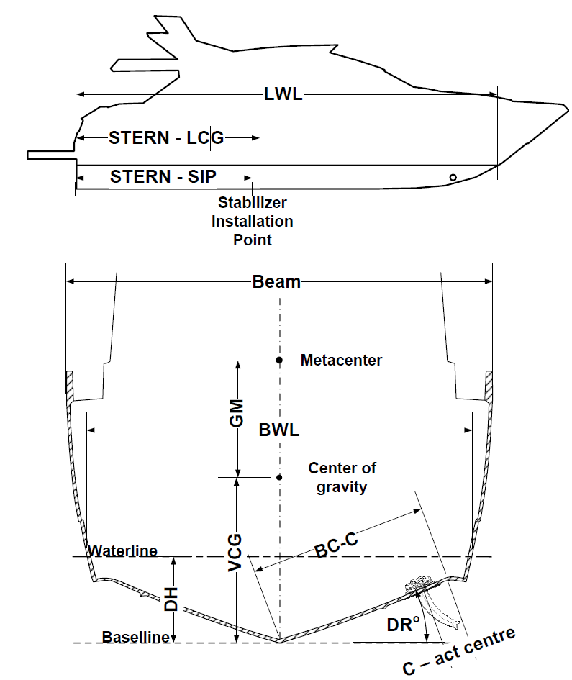
LOA: m LWL: m
BEAM: m Draft: m
Displ: kg @ load condition:
GMt: m @ load condition:
Max speed: kt Cruise speed: kt
Distance STERN -> LCG: m
Distance STERN -> Stab installation point: m
Beam + BWL (beam at waterline): m
VCG (vertical center of gravity): m
Radius of gyration / tested roll period: m / sec
DH (draught hull): m
DR° (deadrise where stab installed): °
BC-C (along hull, bottom to where chine starts): m
Chine to actuator centre: m

For full SIMULATIONS, please also supply:
1. For finding the base factors we need complete 3D
of hull with underwater parts (rudders, shafts etc.) in *.stp
2. For visual view in simulator a complete boat 3D is
preferable for best visualization, but hull only can be
used – in formats *.stl or *.3ds
Please send to: ronny@sleipner.no; jan.erik.johansen@sleipner.no
We guarantee the confidential handling of your model files
and data!

Other comments:

Filled out by: Date:

Hydraulic system questionnaire_v1.2.docx
2020-12-14. R.Holm
File unlock: “Sleipner”

